Introduction
As an island nation, the Philippines is home to over 500 Marine Protected Areas. It is located in the middle of the Coral Triangle, which is the richest marine region in the world, with over 52% of the world's marine species occurring in this area. On land, due to it's many islands, the level of endemic species is also very high. Human pressure on both these areas is high though. The regulation of over-exploitation of these ecosystems (deforestation and over-fishing) is receiving ever more attention. For marine ecosystems though, over-fishing is hardly the only threat, with water quality problems like ocean-acidification, siltation due to coastal runoff, algae blooms and rising sea-water temperatures having a large impact on the resilience of marine ecosystems. On land, pollution by human activities may also have wide-reaching, but hard to detect consequences. In all aquatic ecosystems, gradual changes in water quality can lead to a tipping point in the ecosystem. Although these gradual changes are hard to see with the naked eye, once a tipping point has been reached, drastic changes occur very rapidly, from which it is hard to recover. Water quality monitoring is therefore important, both on land in at sea. Often this is done with slow, labor and knowledge intensive methods, which require well-equipped laboratories, and in the case of marine ecosystems even SCUBA equipment, which requires technical training and funding.
With ever cheaper and power efficient electronic sensors, many of the important water quality parameters can nowadays be measured electronically, with equipment that doesn't require highly trained people to deploy instruments in the field. This project aims to develop a low-cost water quality measurement station that is able to continuously record water quality data for an extended period of time. The following parameters will be measured:
- Dissolved oxygen
- Electro-Conductivity (measure for salinity and dissolved ions)
- pH
- Temperature
- Turbidity
- Light attenuation at different depths for monitoring sources of high turbidity (algae vs siltation)

Scope
This project will be undertaken as a research and development project, resulting in a proof-of-concept. It is a continuation of the Waterspace arts incubator project run by Dr Andrew Quitmeyer and Foundation University, sponsored by the US State Department and ZERO1. Most of the sensors and electronics needed for this project will be made available by Foundation University as their counterpart.
All code, designs, documentation and other work will be documented and released under the GPL open-source license to make the use and improvement of all materials possible by anyone without cost. All materials purchased and used for this project will be owned by the Nightowl technology incubator, part of Foundation University.

Design and requirements

Requirements
- Waterproof, anchored housing
- Usable in fresh and salt water
- Following parameters
  - Light attenuation of broad spectrum white lightm and green and blue wavelengths
  - pH
  - EC
  - dissolved oxygen
  - Temperature
- Recording to SDcard
- Multiple day operation

Design
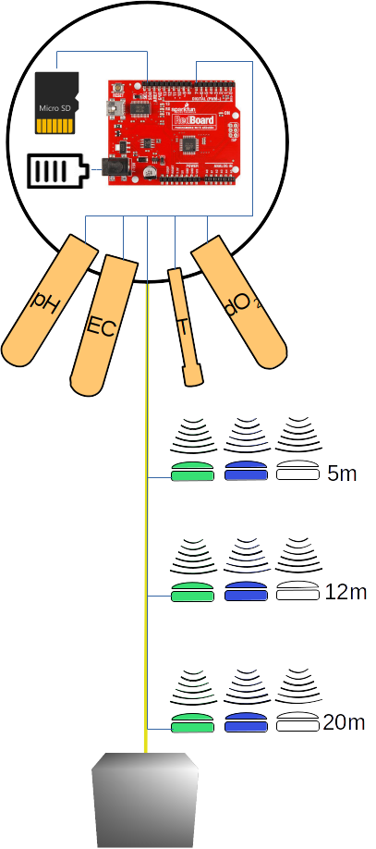
The platform will be based on an Arduino UNO compatible board. This contains I2C, analog, SPI and GPIO pins enough to connect the whole range of sensors. It will be running on 3.3V from 18650 Li-ion batteries. If necessary, a small solar panel could be added to recharge the batteries during the day. Data will be recorded once every 15 minutes initially and recorded to a micro-sd card. The whole platform will be housed in a water-proof container, preferably a buoy, that can be opened and closed. The buoys will contain waterproof holes in the bottom to allow the waterproof sensors to connect to the electronics inside the buoy. A rope will extend down from the buoy to mount the sensors to, and to allow anchoring of the buoy on a sinker.
The following sensors will be used:
Parameter | Sensor | Range and resolution
Dissolved Oxygen | Atlas Scientific dissolved Oxygen kit | 0.01mg/l - 35.99mg/l +/-0.02mg/l
pH | Atlas Scientific pH kit | 0.001 – 14.000 +/-0.02
EC | DIY EC sensor
Turbidity | Luminosity sensor at 2 depths
Light attenuation | DIY version of the Rainbow sensor using RGB sensors and White light luminosity sensor
Temperature | Dallas waterproof one-wire temperature sensor | -55°C - 125°C (+/-0.5°C)

Project deliverables
Milestone | Title | Due date
1. | Working pH and dOx sensors
2. | EC measurement working
3. | Turbidity sensor operational
4. | Rainbow sensors operational
5. | Prototype version tested in the field
6. | Optimized power consumption
7. | Final housing finished
8. | Final version tested in the field

Budget

Materials
Materials
Item | Link | Qty | Price (PHP) | Total
SD-card slot | https://www.amazon.com/Card-Reader-Module-Socket-Arduino/dp/B008B52QQC | 4 | 400.00 | 1,600.00
Atlas Scientific Dissolved Oxygen Kit | https://www.sparkfun.com/products/11194 | 3 | 13,000.00 | 39,000.00
Atlas Scientific pH Sensor Kit | https://www.sparkfun.com/products/10972 | 3 | 6,500.00 | 19,500.00
Dallas One-Wire temperature sensor | https://www.sparkfun.com/products/11050 | 3 | 500.00 | 1,500.00
Sparkfun RGB sensor | https://www.sparkfun.com/products/12829 | 24 | 400.00 | 9,600.00
Sparkfun Luminosity sensor | https://www.sparkfun.com/products/12055 | 12 | 300.00 | 3,600.00
ABS 3d printing filament | http://ph.rs-online.com/web/p/3d-printing-materials/8320368/ | 1 | 2,500.00 | 2,500.00
Li(ion/po) Batteries 3500mAh |  | 8 | 300.00 | 2,400.00
Lee Filter #124 Dark Green | http://www.ebay.com/itm/Lee-124-Dark-Green-Lighting-Gel-Filter-Sheet-21-x-24-/360653862319 | 1 | 700.00 | 700.00
Lee Filter #798 Chrysalis Pink | http://www.ebay.com/itm/Lee-Filters-Lighting-Gel-Sheet-798-Chrysalis-Pink-/291671443403 | 1 | 700.00 | 700.00
Atmega328PU Microprocessor | http://www.mouser.ph/ProductDetail/Atmel/ATMEGA328-PU/ | 4 | 200.00 | 800.00
Adafruit DS3231 Precision Real Time Clock chip | http://www.mouser.ph/Search/ProductDetail.aspx?R=3013virtualkey54850000virtualkey485-3013 | 4 | 750.00 | 3,000.00
Various small electronics |  | 4 | 200.00 | 800.00
Custom printed circuit board | https://www.itead.cc/open-pcb/pcb-prototyping.html | 4 | 150.00 | 600.00
Total |  |  |  | 82,650.00

Other costs
Item | Quantity | Price (PHP) | Total
Scuba tank rental for validation data collection (3 days, 1 dive with 2 people per sensor platform per day) | 24 | 300.00 | 7,200.00
Boat rental (3 sampling days, transport to each of the sensor platforms ) | 3 days | ?
Transport to sampling sites (3 days)

Work breakdown

Interesting links
- http://nsuworks.nova.edu/cgi/viewcontent.cgi?filename=119&article=1000&context=occ_icrs&type=additional
- https://www.raspberrypi.org/blog/satellite-ocean-monitoring/
- http://marinebio.org/oceans/temperature/
- http://www.instructables.com/id/Measuring-salt-concentration-with-AC/
- http://hackaday.com/2014/11/10/accurately-measuring-electrical-conductivity/
- http://electronics.stackexchange.com/questions/161121/water-conductivity-measurement-ac-interfacing-with-arduino
- http://fosc.org/WQData/WQParameters.htm
- http://www.fondriest.com/environmental-measurements/parameters/water-quality/conductivity-salinity-tds/
- http://scienceinhydroponics.com/2009/02/faq-electrical-conductivity-ec-in-hydroponics.html

