Introduction
Balinsasayao Twin Lakes Natural Park is a mountainous natural park of 80km2 in the Cuernos de Negros mountain chain between Dumaguete, Sibulan, Valencia and San Jose. It contains one of the last stretches of primary forest in Negros, and the Philippines. Economical interests and illegal deforestation put pressure on this last stretch of highland tropical forest. To put a halt to the illegal deforestation, the PAMB (protected area management board) of the park wants to more tightly monitor the stretches of forest. Due to the size of the park and limited personnel availability, it takes a lot of time to monitor the whole park on foot. To aid their monitoring they looked at the possibilities of a technological solution to aid the monitoring. At a presentation of the PAMB, the Nightowl Technology Incubator and Hackerspace of Foundation University was asked if UAV's (drones) could be an option in monitoring this area. Due to the limitations of flight time (around 20min) and signal range (3km) of remote controlled drones, regular drones are of limited use for this purpose. Autonomous UAV's on the other hand that would not depend on a human operator within it's signal range, and can recharge independently when batteries are low, could have a much greater effective monitoring range, while being able to operate continuously without human intervention. This would greatly improve monitoring capabilities. Commercial autonomous UAV's are cost-prohibitive for this application though. We therefore propose to develop our own low-cost autonomous drone platform, based upon existing open source hard- and software. Using this drone platform, assistance could be given to the Balinsasayao Twin Lakes Natural Park and other interested organisations who need assistance in monitoring deforestation and reforestation. The platform would also lend itself to additional development of remote-sensing capabilities later on.
Since this project is pushing the boundaries of UAV's, it will require many different technologies to be applied and combined and possibly developed. As such it is an ambitious project that requires a lot of research and development, and the outcome is far from certain. The Nightowl Incubator and Maker-Space, under the supervision of the Foundation University College of Computer Sciences, where ambitious students and makers are available, is the ideal location to take on this long-term project, and tackle the problems one by one. Financial aid needs to be found form DENR, DOST and other government agencies, and partnerships need to be found with other groups within and outside universities to get the best people together.

Scope
This project will be purely an R&D/prototyping project. The goal is to investigate whether it is possible to develop a UAV system with a limited budget and technical resources, that is able to operate without human intervention or purely remote human intervention from several kilometers away. This is only possible when using as many existing open-source software and hardware as possible. There are many aspects and requirements to this project that are all ambitious. Some of the aspects of the project might have the outcome that more work is needed, or the required technology doesn't exist yet or is still cost-prohibitive at this time. A step-by-step approach will therefore be taken where the project is divided into three phases that will be taken on one-by-one. Between each phase, the progress, hurdles and opportunities will be reviewed.
This project proposal only covers phase 1, which will encompass building a drone that is able to fly without direct human control between two GPS coordinates, preset on the drone before take-off, while taking pictures or video along the way. An effort will be made to make the flight time and distance as long as possible, and make the recovery of the drone possible in case of problems.

Ownership
All components and software that needs to be developed within this project will be made available under an open-source license, and will be published online, available to the general public. This will enable the continued development of the platform by Foundation University and other inside and outside the Philippines. At least three test sessions will be held in Balinsasayao Twin Lakes Natural Park and all data gathered there will be shared with the PAMB and other interested parties. The drone and all materials bought and developed during this project will remain the property of Foundation University.

Design and requirements
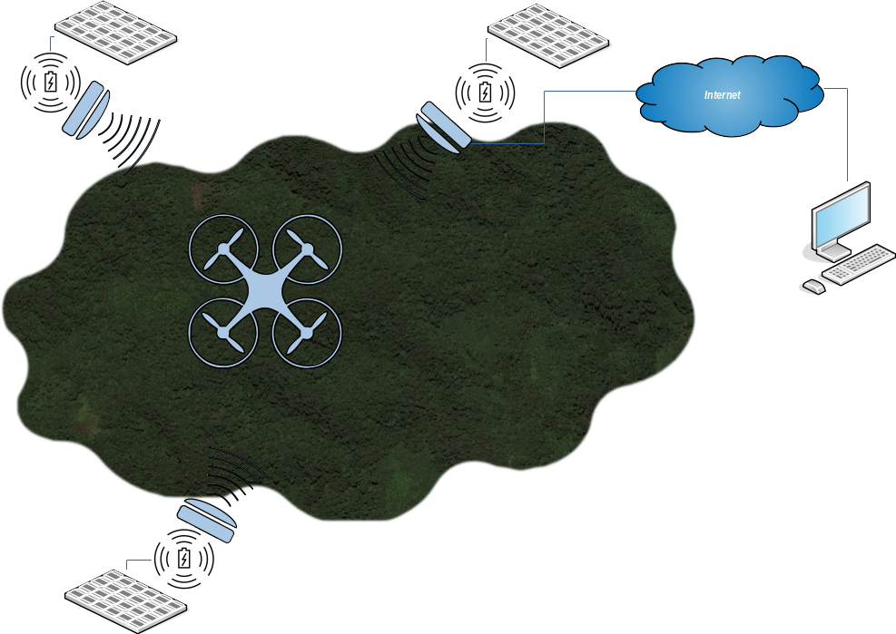
The final goal of this project is to have a UAV that can operate without human intervention in monitoring deforestation in a relatively large area. To accomplish this, base stations are necessary where the drone can land, charge, receive commands, and shelter from bad weather. When commanded by a central management application, the drone will take off and independently fly to another charging station, while taking pictures. The charging stations need to be able to communicate between eachother and the drone to receive and send commands, which would be possible using a wireless mesh. A central controlling computer needs to be able to send commands to the drone and charging stations to plan the route of the drone, taking weather conditions, flight time and monitoring progress into account.

Risk assessment
We can run various risks with the project that need to be addressed. The following are the most important risks and their mitigation.
Risk | Mitigation
Technical complexity of the project | Split the program into several phases and handle them one by one
 | Use as much existing open-source software and hardware
Damage due to crash landing in the trees | Budget available for spare parts
 | 3D printer available to create replacement parts
 | Fly low over trees
 | Test in low-risk area
Drone lost due to crash | Beacon and antennas for locating the drone
Water damage due to crash landing over water | Only fly over land

Existing technology and software
- Ardupilot software for routing of autonomous flying drones
- Pixhawk open-source drone controller for autonomous operation
- Dronecode open-source software development ecosystem for UAV's
- Inductive charging

Requirements

The UAV
- Be able to fly over land only between base stations of a fixed, known location, in an area without obstructions above a minimum altitude
- Land at the base stations accurately enough to allow wireless charging
- Record photo or video data along the way
- Possibly transfer the data at the base stations after landing
- Possibly receive instructions from the base stations and/or a central management tool/person for the next flight
- The UAV should be easily locatable in case of a crash or other problem
- It should be able to charge it batteries wirelessly
- Water proof for water crash?
- Wireless communication throughout flight to relocate it later on?

Base station
- Provide electricity to charge the drone batteries (solar?)
- Be able to charge the drone batteries wirelessly
- Provide a dry and shaded area for the drone to recharge, but also land and take-off accurately
- Optional: through a mesh network or cellphone reception connect to a centralized management application on the internet
- Optional: Communicate simple instructions to the drone for route planning

Central management application
The necessity of this application is not certain and depends on the possibilities of the drone and it's base station. Optional requirements could be:
- Monitor weather conditions to evaluate of they are suitable for the UAV to fly
- Plan the route of the UAV
- Provide a log of the activities and different metrics of the UAV and it's base stations
- Monitor the location of the UAV in case of problems
- Provide information on the health of the UAV and base stations and notify a user if required

Locating the drone after crash
- The NRF24L01+ with antenna, PA and LNA (power amplifier and low noise amplifier) can have around 300-1000m range, we could use that to transmit the location of the drone in flight, so we know where it goes down. Disadvantage is it's bulk and probably larger battery requirement (and thus weight). We could also use it to keep sending the drone GPS coordinates out on 2.4GHz from the GPS module. See http://www.elecfreaks.com/wiki/index.php?title=2.4G_Wireless_nRF24L01p_with_PA_and_LNA. The price is good at around $15 for two modules. See http://www.ebay.com/itm/2-x-NRF24L01-PA-LNA-SMA-Antenna-Wireless-Transceiver-communication-module-2-4G-/111853679356
- Loc8tor lite is a tag with locator that can find the tag back accurately from 122m: http://www.loc8tor.com/everyday/loc8tor-lite.html/ This would be good for the last little stretch in a forest, but costs $90.
- A complete, but expensive solution is from the Marco Polo locator at close to $300. http://eurekaproducts.com/product-category/buyrcmodelsystems/
- A DIY telemetry kit with around 700m range (open field) is possible for around $20 as well. This seems a very good option right now. See https://quadmeup.com/diy-wireless-telemetry-link-for-uav/

Precision landing
There is an irlock module available for precision landing. It is an IR sensor that centers the drone over a location. It is compatible with the dronecode/ardupilot suite of software. See http://ardupilot.org/copter/docs/precision-landing-with-irlock.html

Deliverables
Deliverable | Phase | Title | Due date
1. | 1 | Finalize current proposal | Sep 2016
2. | 1 | Get funding commitments | Okt 2016
3. | 1 | UAV controller circuitry complete | Dec 2016
4. | 1 | UAV can receive instructions through wire to fly to GPS coordinates | Feb 2017
5. | 1 | Drone localisation and retrieval possible form 1km away | Mar 2017
6. | 1 | Hook-up a camera system to the drone | Mar 2017
7. | 2 | Drone can land on base station
8. | 2 | Base station design complete
9. | 2 | Wireless charging works
10. | 3 | UAV can receive commands wirelessly
11. | 3 | Base stations can communicate in a mesh configuration
12. | 3 | UAV can receive instrcutions from a central management application
13. | 3 | Central management application can plan drone flight for multiple drones

Budget

Materials
Item | Link | Qty | Price (USD) | Total
Drone platform |  | 1 | 30 | 30
Wireless communication module (NRF24L01+PA+LNA) | http://www.elecfreaks.com/wiki/index.php?title=2.4G_Wireless_nRF24L01p_with_PA_and_LNA | 2 | 15 | 30
Pixhawk Drone controllerboard/IMU with GPS | https://www.unmannedtechshop.co.uk/unmanned-pixhawk-autopilot-kit/ | 1 | 240 | 240
HC-12 Wireless Drone locator Module | http://www.ebay.com/itm/433Mhz-HC-12-SI4463-Wireless-Serial-Port-Module-1000m-Replace-Bluetooth-Module-/131167660092 | 2 | 20 | 40
Go-pro camera |  | 1 | 0 | 0
ABS 3d printing filament | http://ph.rs-online.com/web/p/3d-printing-materials/8320368/ | 1 | 45 | 45
Li(ion/po) Batteries 3500mAh |  | 6 | 8 | 48
Total |  |  |  | 433

Personnel costs
Role | FTE (monthly?) rate | Number of days | Total
Research assistants
Researchers
Project manager
Consultant
Academic Program manager

Work breakdown
Deliverables
- Finalize current proposal
  - Finalize design requirements for first proposal
  - Research combination of flight time, range and wireless signal strength on 2.4GHz (possibly with nrf24L+)
  - Research accurate landing (laser, infrared, etc)
  - Research drone controllers, IMU and GPS communication
  - Research routing software (mission planning/operation)
  - Research altitude navigation for landing and sensors
  - Research flight duration
  - Get a list of materials
  - Finalize milestone list

Interesting links
- https://www.dronecode.org/dronecode-software-platform
- http://elinux.org/images/4/49/Autonomous_Navigation_for_an_OMAP4_Nano-Drone.pdf
- http://px4.io/
- https://pixhawk.org/
- https://store.3dr.com/products/3dr-pixhawk
- http://ardupilot.org/copter/index.html
- http://www.auav.co/category-s/100.htm
- https://en.wikipedia.org/wiki/Unmanned_aerial_vehicle#Autonomy
- Wireless charging for the Base stations: http://www.instructables.com/id/Wireless-Electricity-Transmission-Simple-things-re/
- http://diydrones.com/
- http://copter.ardupilot.org/ardupilot/index.html
- http://ardupilot.org/ardupilot/index.html
- https://ultimaker.com/en/community/5549-how-weatherproof-is-pla
- https://docs.google.com/document/d/10MgFocP4nxi_uPrZQDXdhGncASnwSeg1XHiWnK9IcvI/edit?usp=sharing

