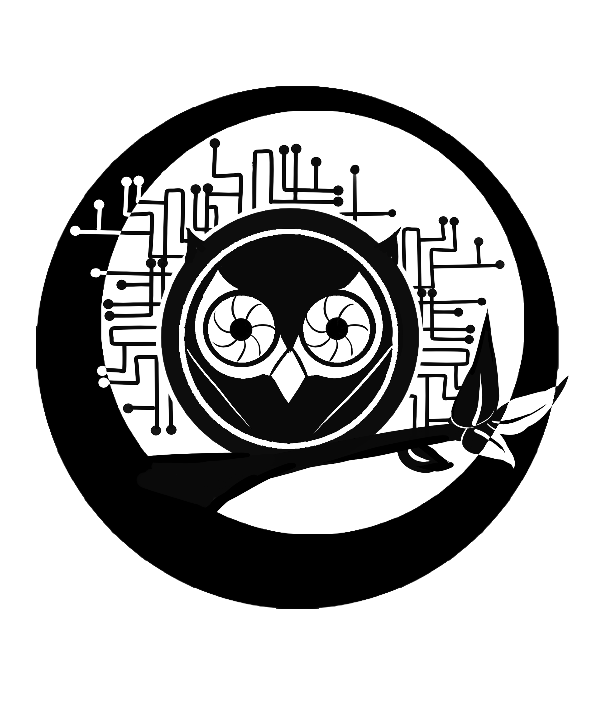
NightOwl is the first hacker/maker space in Dumaguete City, The Philippines. The goal of our project is to utilize technology and art to grow and contribute to the community. NightOwl is supported by Foundation University.
Our members are from all walks of life; Filipino, foreign, students from different universities, professionals as well as volunteers. All of us want to build cool stuff and learn from each other in the process. We think this is the best and most fun way to learn.
We are located at the ground floor of the L.G. Sinco IT Building of Foundation Universities College of Cmputer Studies. Most weekdays we are around so feel free to come and have a look.
The main space is open to anyone who's interested on Wednesday's starting in the late afternoon.
If you're interested, drop us a message at info@nightowl.foundationu.com. Make sure to also check out the contact page!

